1. **Command** 🡺 **docker version**   
   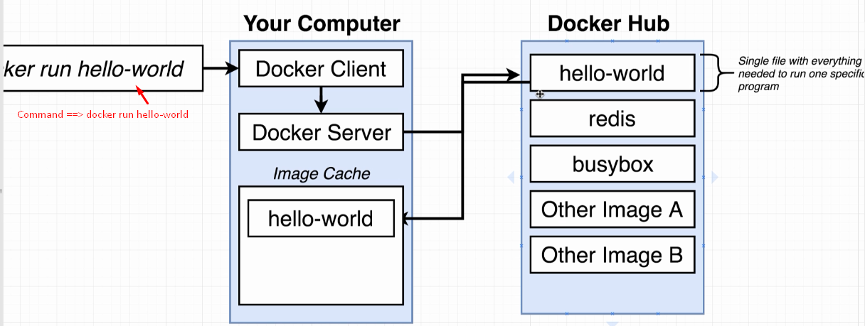
2. Now, I want to write out our very first kind of meaningful command with the dock or client or the Docker CLI.
3. 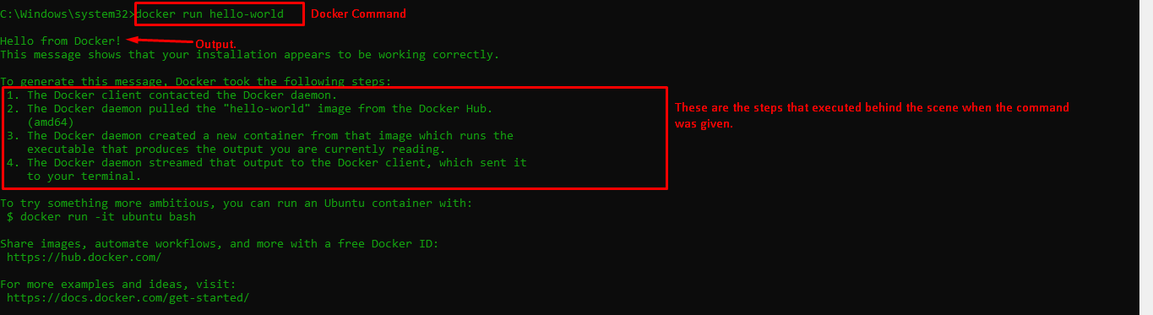

Let’s study what happened behind the scene.

* 1. The command starts up Docker client CLI which is in charge of taking commands from you kind of doing a little bit of processing on them and then communicating the commands over to something called the Docker Server.
  2. Docker Server is really in charge of the heavy lifting.
  3. That command means that we want to start up a new container using the image with the name of “hello-world”.
  4. The hello-world image has a tiny little program inside of it whose sole purpose is to print out the message that you see right here.  
     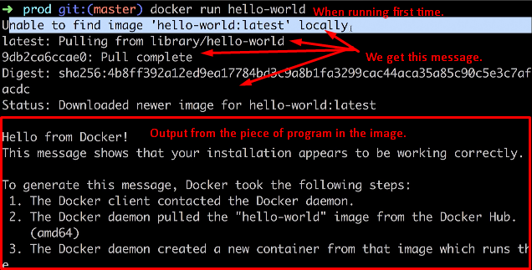  
     **NOTE**:
  5. First Docker Server checks weather local server has a copy of “hello-world” image. The Docker Server would look into the “**image cache”  
     As** we just installed Docker, the image cache is empty.
  6. So, Docker server reaches out to a **free service** called **Docker Hub**. Docker Hub is a repo of free public images that you can freely download and run on your personal computer.
  7. Docker Server downloads the image from Docker Hub and stores into “**Image Cache**”.
  8. Docker Server then loads that single file (image) into memory, then creates a container out of it and then runs a single program inside of it.  
     